# Ayeka

The following is the estimated power consumption:  
• Digital board: Maximal 40W + 5.6W regulators power consumption for both digital and  
digitizer  
• Wideband digitizer: Maximal16W  
• Ka Up down converter: 9W per channel.  
• Total: 70W for a system with single Ka band TX/Rx channel.  
• Actual consumption depends on the specific implementation.

Questions:

Digital board: Maximal 40W + 5.6W regulators power consumption for both digital and digitizer

# Ramon

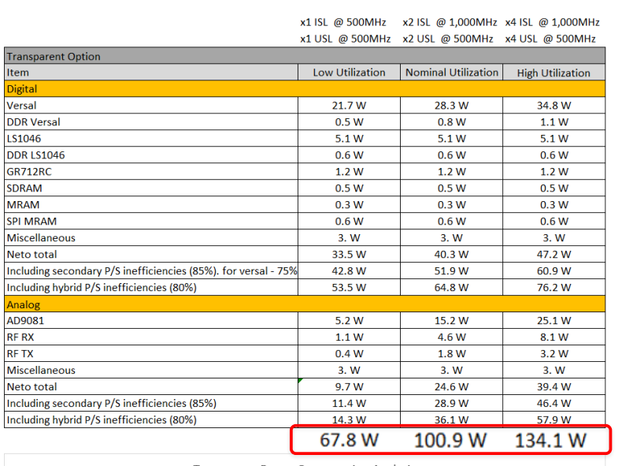

|  |  |  |
| --- | --- | --- |
|  | Ramon | Ayecka |
| Digitizer (2 x full rx and tx) | 5.2 |  |
| Up/down converter (2 x full rx and tx) | 1.5 x 2 |  |
| Digital (2 x full rx and tx) | 53.5 |  |